**(42) Mineral Resources**

Mineral:

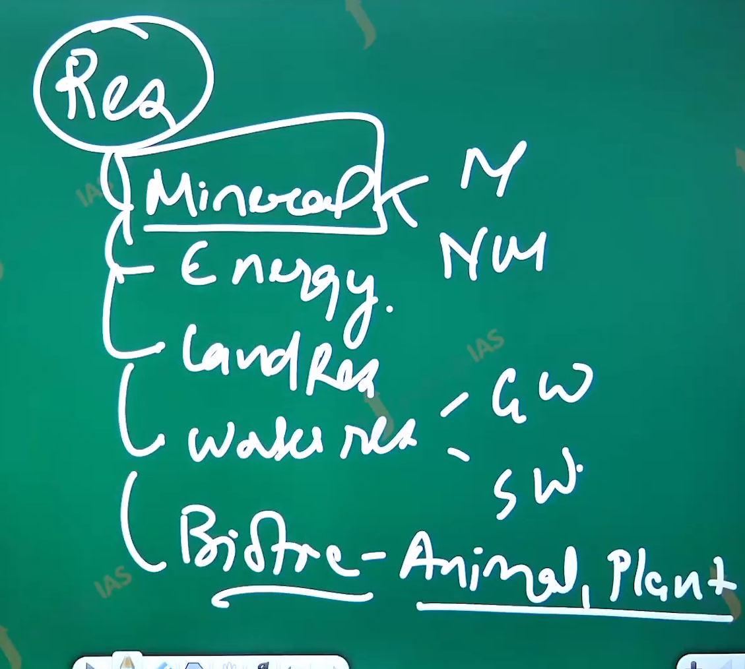

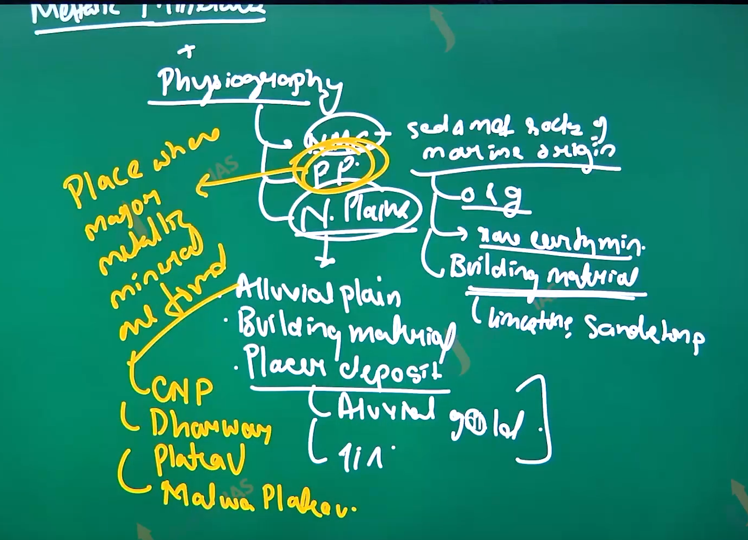

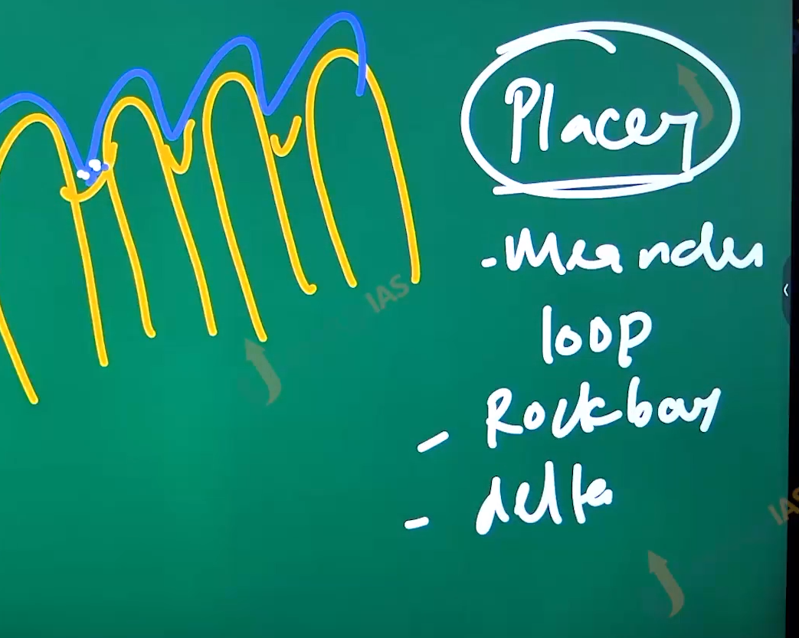

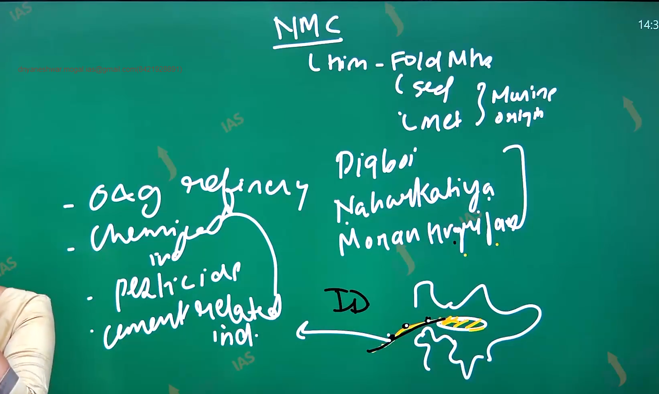

Linking photography of India:

1. Himalayas are made up of sedimentary and metamorphic rock of marine origin therefore it has the oil and gas. ex. oil and gas found in the assam region. Dig boy Nahar Katiyar, Moran hegari Jahan, Moran hugrijan. We have coal resources in Udhampur,jarori. The best type of coal (anthracite) coal is found in the karakul, Kashmir.

Northen plane:

1. Northern plans are accumulation of sand silk, and deposits brought by the Himalayan River. Therefore, they do not have much minerals river,
2. In the western side of the north plane (towards the Rajasthan) there is accumulation of salt and Gypsum.
3. Along the north plane there are placer deposits(placer deposits are material accumulated by agent of denudation like gracer winds and rivers) ex. Alluvial gold, alluvial silver.
4. In India alluvial gold have been found in the Sovern Rekha River.

Peninsular plateau:

1. It has bulk of minerals resources of India with minerals like iron ore gold ore, copper, coal, the major regions where minerals are found are Chhota Nagpur plateau ,Dar War, southern Aravali.

Factors affecting distribution the minerals:

1. Geological factor:
   1. Type of rock: shield area has metallic minerals iron ore in Chhota Nagpur plateau, drawer and Bundelkhand, southern Aravali.
2. Tectonic factor: Coal regions of India are seen in the rift valley ex Narmada, son, Godavari, Damodar.
3. Biological factor: formation of oil and gas.
4. Climatic factor: leaching of silica and accumulation of iron, aluminum leads to formation of bauxite seen in the Odisha: Koraput, bolangir, Kalahandi.balaghat in MP, high land and western ghat and, eastern ghat.

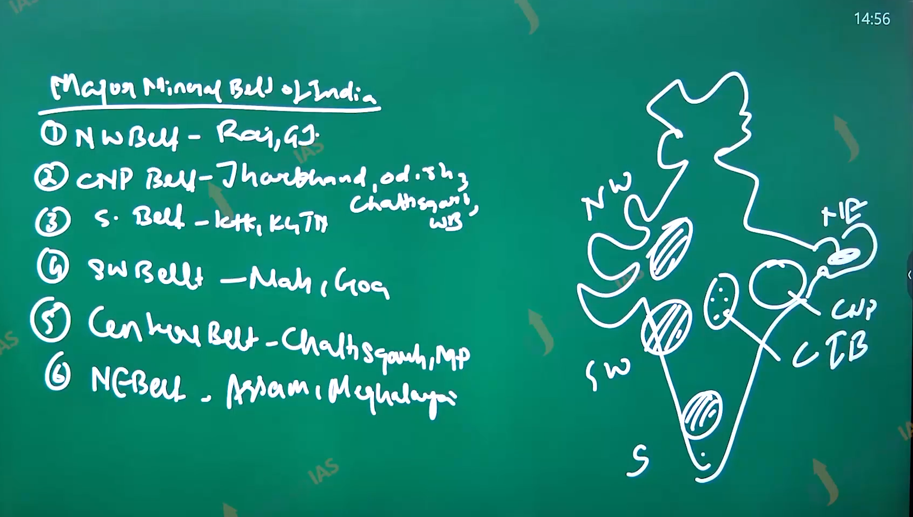

Chhota Nagpur plateau belt:

1. Mineral heart of India. It shields the area and is hub of iron ore, Magnis and aluminum.
2. A coat is found along the river Damodar and its tributaries.
3. Some name of important mine ex zawiya coal field in the Jharkhand, Rani gang coal field in the west Bengal, Iron ore in Palau district, Kodama mines have world largest mica mine, resources of chromite in the Odisha. Copper mine which name is rakes mine, Uranium mine:jaduda mines

Southern belt:

1. It include the state of Tamilnadan and Andhra Pradesh , Karnataka,
2. The minerals found are Iron ore, gold, mica. Iron ore are Dharwad regions, gold ramagiri gold fields in AP, kolar gold fields, hatti, gold, field, mica mines in the neroli district in AP,

Southern western belt:

1. It includes the states of Maharashtra, goa and Karnataka.
2. Minerals found are Iron ore bauxite, coal. Bauxite is found in the satara region, Ratnangi region, coal can be found in Wardha.
3. Iron ore Lohara mines
4. Some parts of Karnataka are also included in the southwestern belt with iron ore resources. Baba badan hills. Phosphate mine Bellary mines.

Central India belt.

1. It includes the state Chhattisgarh, MP, some parts of Odisha. The resources found are coal, bauxite, iron ore,
2. Coal in the Mahanadi River, corban, Bilaspur, zilmili.
3. Iron ore Dalli raj hara bella daiala, Mines district durg and baster
4. Odisha bauxite, kbk (korapur, borandi , Kalahari, ) district and the malli hills.
5. Singrauli coal field towards the son river.

North western belt:

1. It includes the states of Gujrat and Rajasthan. the resource found are salts, building materials, copper, oil and gas, led zinc silver, bauxite,
2. Rajasthan limestone in the Bikaner Udaipur. Marble near the Ajmer makhana marble copper in the Katari mine lead zinc silver.In jawar mines :
3. oil and gas in the magala oil fields.
4. Gujarat:
5. Oil and gas: ankaleshwar, lunage,
6. Bauxite at Amreli, andiyad regions.

Northeastern belt.

1. It includes the state are Assam and Meghalaya. Resources are oil and gas and coal.
2. Oil and gas: Digby, shiv sagar, naharkatiya , moran, hugarijan,
3. Coal makum coal field. In assam,
4. In Meghalaya coal : domiciat mines.
5. Limestone: along nokrek and garo.
6. Uranium: at the mahadekh basin.

Some factor of energy:

1. India’s total install capacity is around the 410 and Gaga watt. And coal accounts for nearly 50% of total installation capacity.
2. The energy mixed from renewable energy is 180 Gaga watts.
3. Coal is the most important energy resource despite 40% energy of mix coming from the renewable energy.

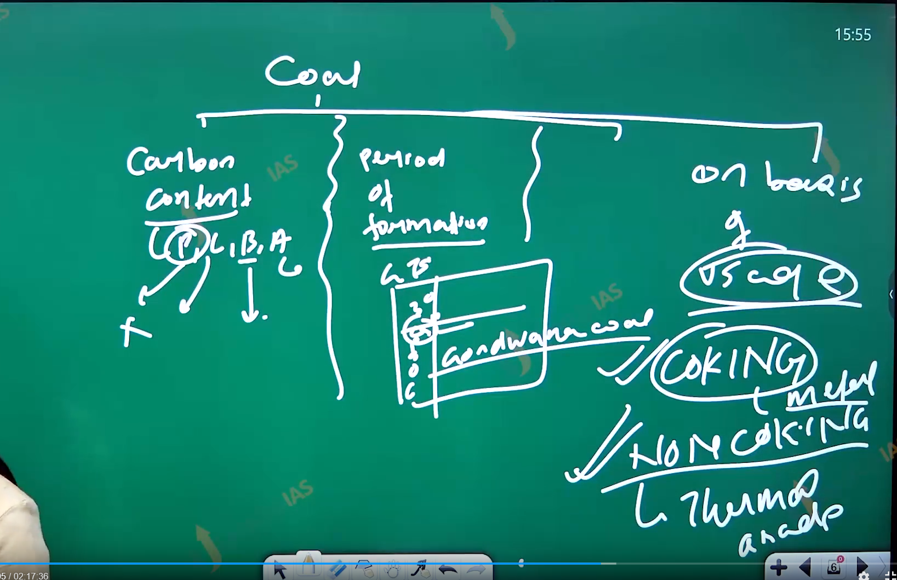

Coal resources:

1. India has thermal grade 315 billion tons of coal reserves. Coal can be classified on the various basis
   1. Formation period: worlds coal resources has been found the early carboniferous periods while the coal field of India below the late carboniferous of India. 98% of coal are Gondwana coal period.
   2. India also has coal that belong to tertiary period like Monsson in the Assam regions navally in the tamilnadu, namchik of Arunachal Pradesh.
2. Classification of Coal on the basis of Uses of coal:
   1. Coking coal: it is used in the metallurgical industry iron and steel industry. It is used in the reducing agent. In India coking coal is found along the zariya coal field.
   2. Non coking coal: 280 billon tons is used in energy production. It is thermal grade coal found in the ranigangj coal fields.
3. Based on Carban containment:
   1. IT can be classified as 4 type
      1. Peat(30,40%)
      2. Lignite (50%)
      3. Bituminous (>60%)
      4. Anthracite( >80%)
   2. Peat is about the first stage in the formation of coal it has high moisture and carbon content is less than 40%.
   3. It found the swampy and marshy areas.
   4. Lignite: it second stage in the development of coal it called brown coal, carbon content is (40%, 60%). Important lignite field makun newdelhi namchin namful.
   5. Bituminous coal: Third stage in the development of coal. The carbon content is 60 to 80. majority of Gondwana coal is bituminous coal therefore seen in the Jharkhand odisha and Chhattisgarh.
   6. Anthracite coal : it best type of coal. Carbon content is greater than95 % free from the moisture as high calorific value in seen in the kalacote.
   7. India has lot of coal resources whoever Indian coal has high ash coal content, and high fusion temperature. It is induction of swathing and melting of fuel ash.
   8. India coal also high in the silica and aluminous, thos the sulfur content is low.

Q. 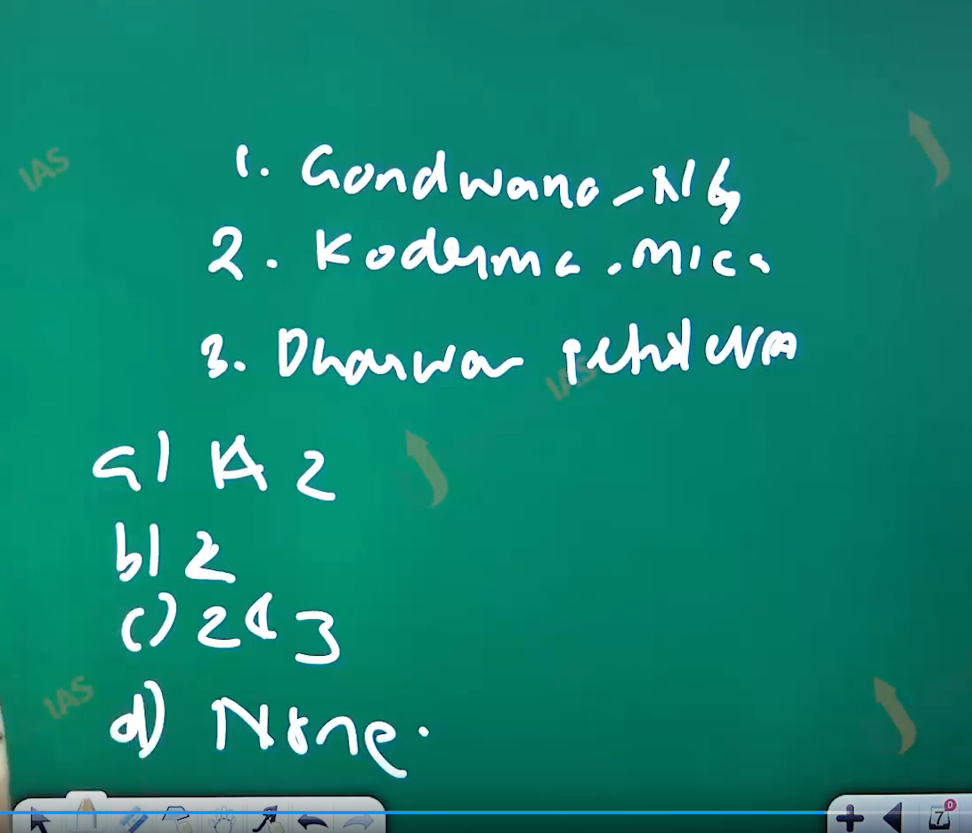

What are the characteristic of the Indian coal:

1. High ash content
2. Low sulfpher content
3. Low ash fusion temperature.
4. 1 and 2\
5. 2
6. 1 and 3
7. 1,2,3.

Ans is A 1 and 2. Temperature is high.

Which of flowing add co2 to the carbon cycle ?

1. Respiration
2. Volcanic action
3. Photosynthesis
4. Decay of organic matter.
5. 1 and 3
6. 2 only
7. 1,2,4
8. All of above.

Ans is C

Which are following conserder as polutent for steels industry>

1. Sulpher
2. Nitrogen
3. Carbon monoxide
4. Coarbon dioxide
5. 1,3,4
6. 2,3,
7. 1,4
8. All of above.

And d

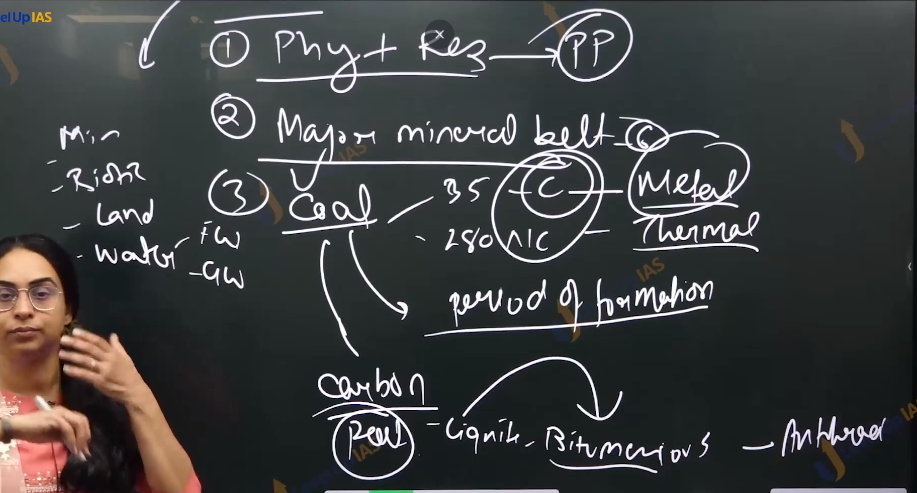

Issue in the Coal sector:

1. Monopoly coal India limited, and the other regulatory issue has compromised the participation of private player.
2. Unscientific mining ex. Rat hole mining in Meghalaya- child labor issue illegal issue, pollution of poli river.
3. The productivity of mining coal in the India is .8 tone output per man shift. As against 40 one which 40 time per man shift.
4. Distribution of coal and demand for energy:
   1. Coal resources are mostly on the eastern side. While power demands are majorly on the western side. Due to the concentration of urban areas in the western side. A pit based (thermal power plant. Near coal mines) have problem of T and D loss and electricity.
   2. A non-pit-based plant thermal power plant has problem of logistic and transport to the thermal power plant. Issue of rolling rake.
5. Other problems: like environmental issues due to disposal of fly ash pollution of air land water. And fire in the coal mine, deforestation, displacement of tribe.

Coal bade methane:

1. along the coal beds the resource of methane gas can be taped in the formed of coal bade methane.
2. CBM is also known as sweet gas. Because it has a very low concentration of hydrogen sulphatic. I
3. India has a lot of coal resources therefore there is huge potential for the CBM. CBM can help in diversification of energy.
4. And it is comparatively cleaner alternatives to coal however there are issue technological unavailability, subsidence of mine, and release of greenhouse gas emissions.

Petroleum:

1. Derived from the word Petra(rocks ) holisms( oil). Therefore, petroleum refers to oil in the sedimentary rock in the India the petroleum reserve the seen in the area of marine transgression. Which include in like Krishna Godavari reason ketch Saurashtra region kathak shell and assam regions.
2. India has two major types of oil field offshore and onshore continental field.
3. Onshore: assam : digboi, naharkatiya, sibsagar, mohanhugrijan.
   1. Gujrat: lunej, ankaleshwar,
   2. Rastan: Mangla oil fields, Rajeshwari oil fields, barner oil fields.
   3. Basin: Bombay high katch, kambat region along the kg basin.

Petroleum refining:

Crude oil : from the oil fields is refined to give petroleum based products like diesel kerosene ,

First petroleum refinery in in the jam Nagar, second in tarpaper in Maharashtra.

Oil and gas pipeline India has 11 thousand kilometer oil and gas pipeline network some important :

1. Hajira, -Vijayapura -Jagdish pipeline
2. Bombay – Bombay highly Omkareshwari pipeline,
3. Mathura to Bathinda.
4. Nahar Kati to neuromata barouni.

Natural gas :

1. Natural gas usually the company’s petroleum accumulation.
2. Whenever the well is drilling for oil it is natural gas available before the oil is struck.
3. India has the huge reserves of natural gas both along the onshore and as well as offshore.
4. Natural gas is important to run the turbines, domestic fuel, transportation of fuel. For production of fertilizer, it nearly accounts 10% of electricity generation.

Electricity:

1. India total installed capacity of electricity is 415 420 giga watt.
2. India however the lags far behind the with respect to consumption of electric India energy mixed is 60% energy generated from the coal and gas. renewable energy is about the 36% (solar energy 10% winds 10% hydro15% bio power 2% nuclear power 2%).
3. Homework: what are the advantages of renewable energy. And scheme for promoting.

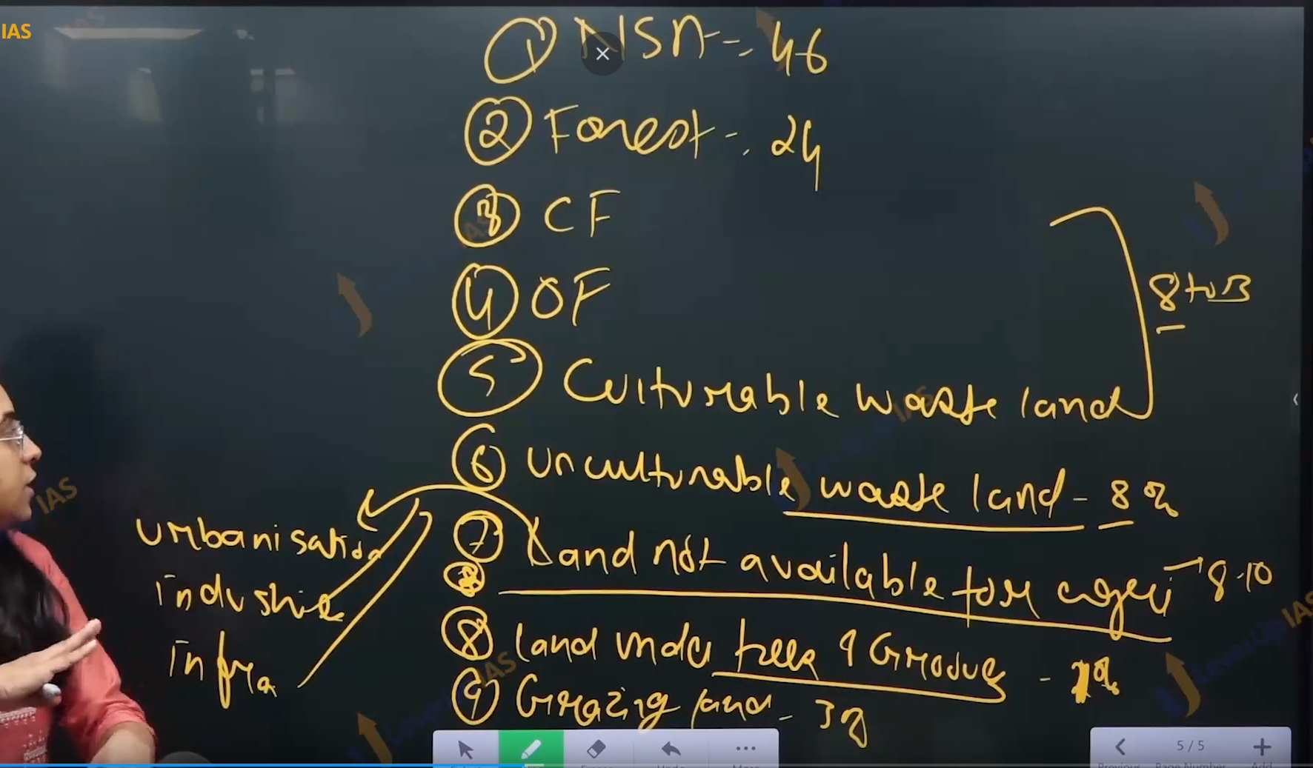

Land resources:

1. In India has 2.4 % of worlds land. With 17 to 18% of the population, therefore there is lot of population pressure on the land resources further there are competing and conflicting the demands. Of land resources in India. Therefore, it8 is important to use land wisely.
2. As per ministry of agriculture departments of land resources there are 9 categories of the land
   1. Net sowed area: 46% Is net sown area
   2. Land under forest 24%
   3. Fallow land less one year and Current fallow
   4. Fallow land one to five year
   5. Culturable waste lands.
   6. Fallow land greater than 5 years.
   7. Land under pasture 3%
   8. Unculturable waste land 8%
   9. Land not available for agricultural (land under the urbanization, infrastructure, road, etc. 5-8%
   10. Land under the tree and groom 3%

Analysis of this figure:

1. For country like India which is land water depended on economy keeping 8 to 10 % of land waste. If land is fallow land. However, some amount of fallow land is needed due to the limit of agriculture and allow the land recouped it’s fertility.
2. Net sown area must be reduced from 46% to 30%. It is also important to keep in mind that agricultural productivity has to meet the food security of country
3. Unculturable waste land can be diverted towards urination and infrastructural need.
4. Land under the forest must be increased 24 to 30 % as per national forest policy recommendations.
5. Land under the pastures needs to increase from 3 to 5/7% as India aims to acquire the food security makes the agricultural produces specially milk produced in the competitor in the raising market.
6. Because aim to reduce the NSA at the same time increase the agricultural productivity it important to divert to most productive land for agricultural. Therefore, we need to classify the land according to capability.

Water resources:

1. Water is one of the most important resources. Water is part of social right and humans right and very important country like India which is land water economy which use the agricultural depends on needs of urbanization/ industrialization, increasing energy consumption.
2. Water resources can subdivide to surface water resources and ground water resources. surface water resources which include river lake tanks pound, glacier. Surface water holds significant in the household water management irrigation needs and agriculture water needs.
3. Ground water 30 % water use is through ground water resources (surface water account 70 % of India total water resources).
4. 90% of ground water is used for agriculture. 5% industrial purpose less 1 domatic water.
5. Irrigation is one of larger water uses with high water used in the efficiency there are distribution losses and evaporation losses and percolation water.
6. Lack of water use sensitivity because of lack of awareness and limited use of technology. Further aggravates the water wastage therefore it is important to use the water at most sensitivity specially in the agricultural and urbanization needs.